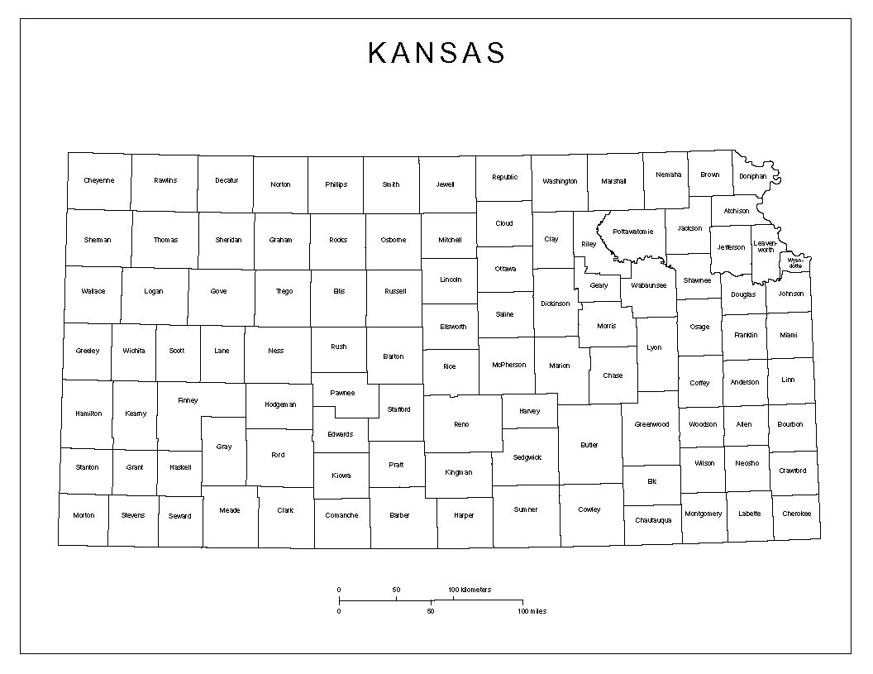

**JO – 620-860-7240**

**DG – 785-330-8602**

**WY/LV -- 316-337-6409**

**Mya Hanson, NC KS**

**785-515-6710**

**Working Healthy Benefits Specialist Regional Map**

**Danielle Mowery, SW KS**

**620-682-7945**

**Earl Williams, NE KS**

**785-330-8602**

**Billie Crawshaw, NW Kansas 785-261-6122**

**Sarah Guardado, SC Kansas**

**316-337-6409**

**Danielle Mowery, Wichita Region 620-682-7945**

**316-337-6012**

**Shelli Nyambane, Southeast KS**

**620-860-7240**